This software was built by 4 student:
1-Ali Livan Türk 200444004
2-Hasan Tuğra Aykaç 200444411
3-Mustafa Karakaya 200444012
4-Muhammet Tarık Öğüt 200444072

This is a Basic Storeroom Management System by Using Tkinter,Opencv and OOP.
In our zip file there is a main.py file, if you want to use this software there are some steps to follow:
Some library must be imported:
Opencv
Pandas
Tkinter
Openpyxl
ttkbootstrap
os

1- Opening
When we start the program, we will see the main menu screen. We have 3 buttons: Check Items, Add Items, and Quit the program. Every button has its own different action to help us do whichever we choose to do.

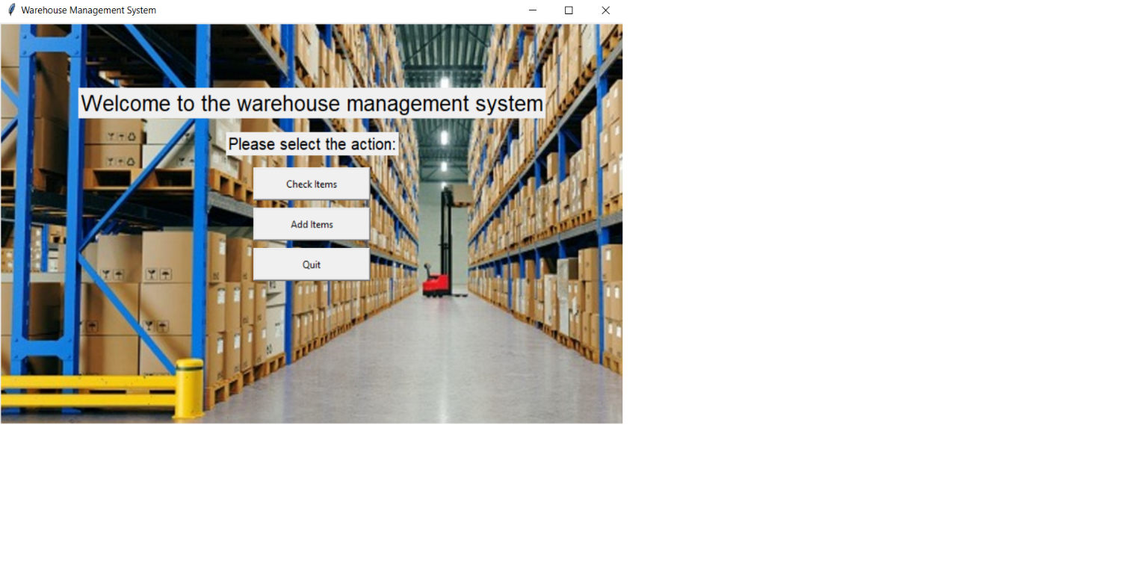

2- The function of Check Items
When we want to see the items whether if they are on the storage or just to check if there is enough amount, we have to click ‘Check Items’ button. This page has only one function.In this page, we have two entry named as Product Code and Raw Material Code . When we want to check for the raw materials, we will have to enter the code of the specific raw material. After entering the storage code of the raw material and clicked the ‘Enter’ key, features of the raw material will be shown in the window.

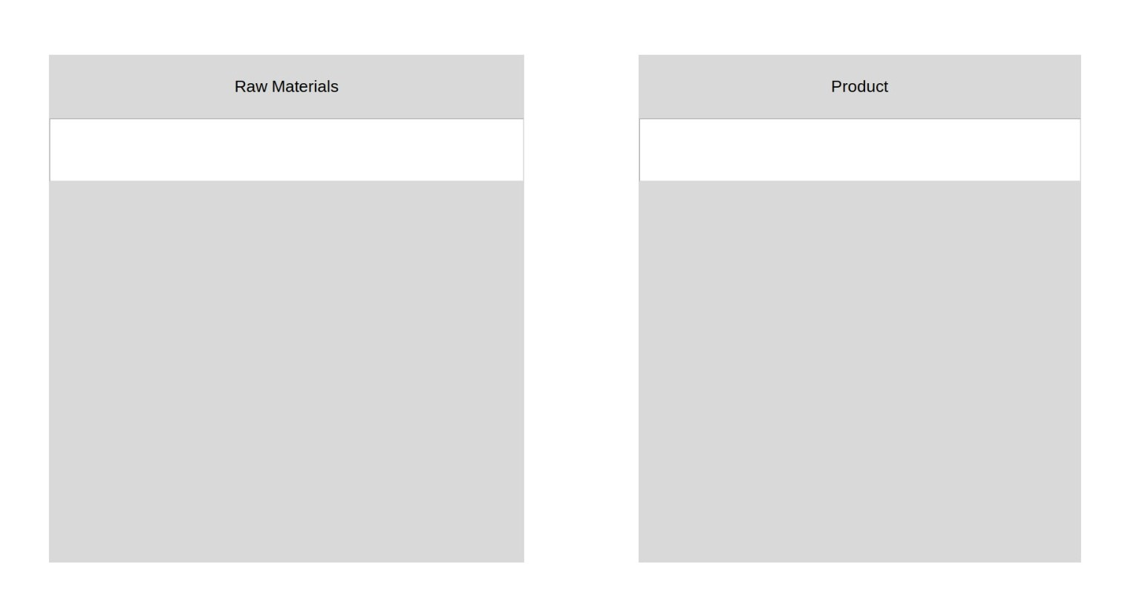

3-The function of Check Items
When we want to add new items to our database, we will have to click the ‘Add Items’ button. After we clicked this button a new page appears.

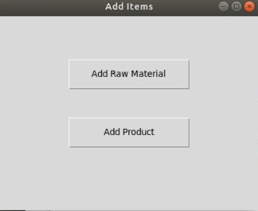

In this page you also have to choices named as ‘Add Raw Material’ and ‘Add Product’. After clicked one of our choices a new window will appear depending on our choice.
First, we will click “Add Raw Material” button.
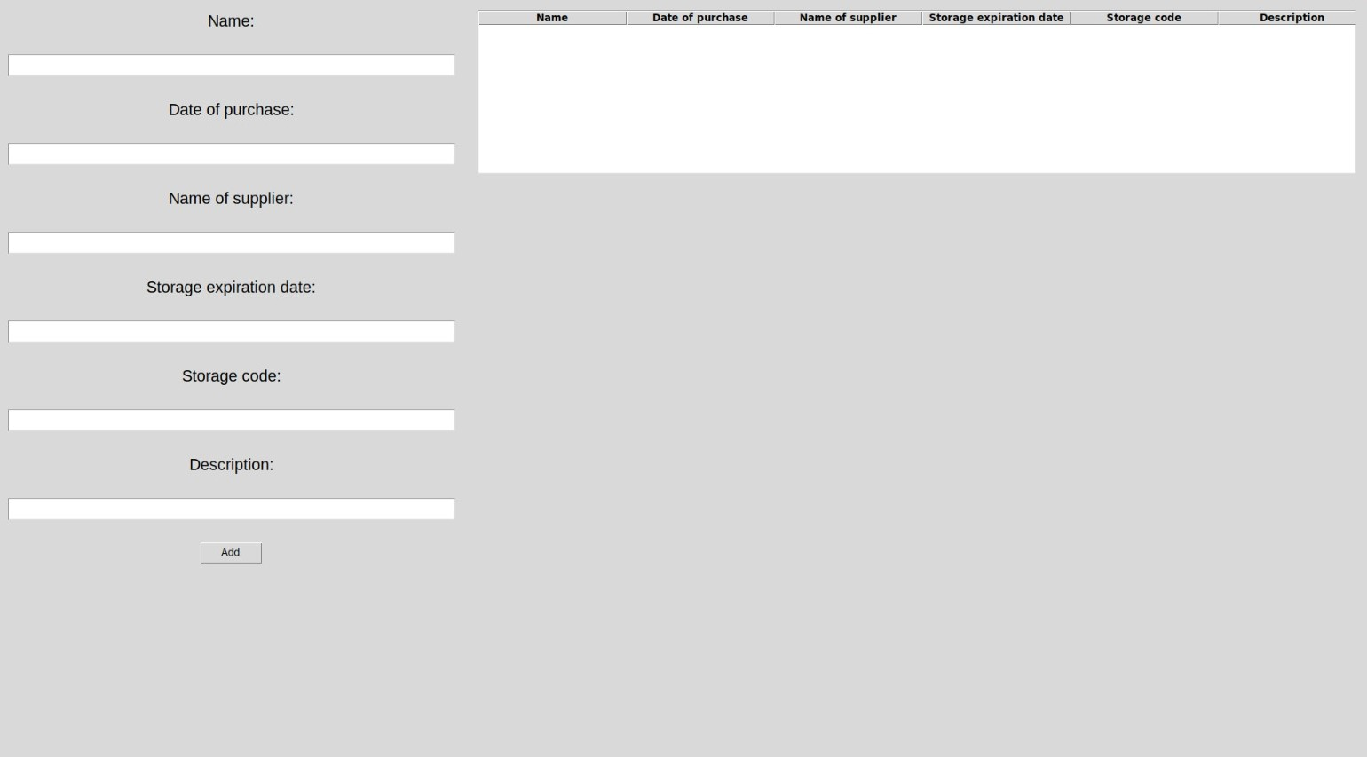

In this page, we can add new items to be saved in the database.

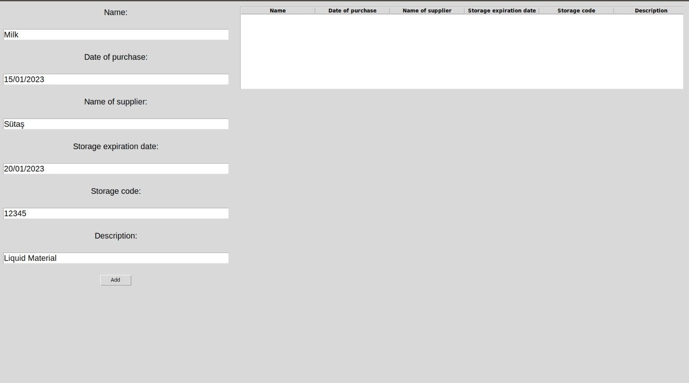
We will enter our new item’s informations to entry widgets then click “Add” button.
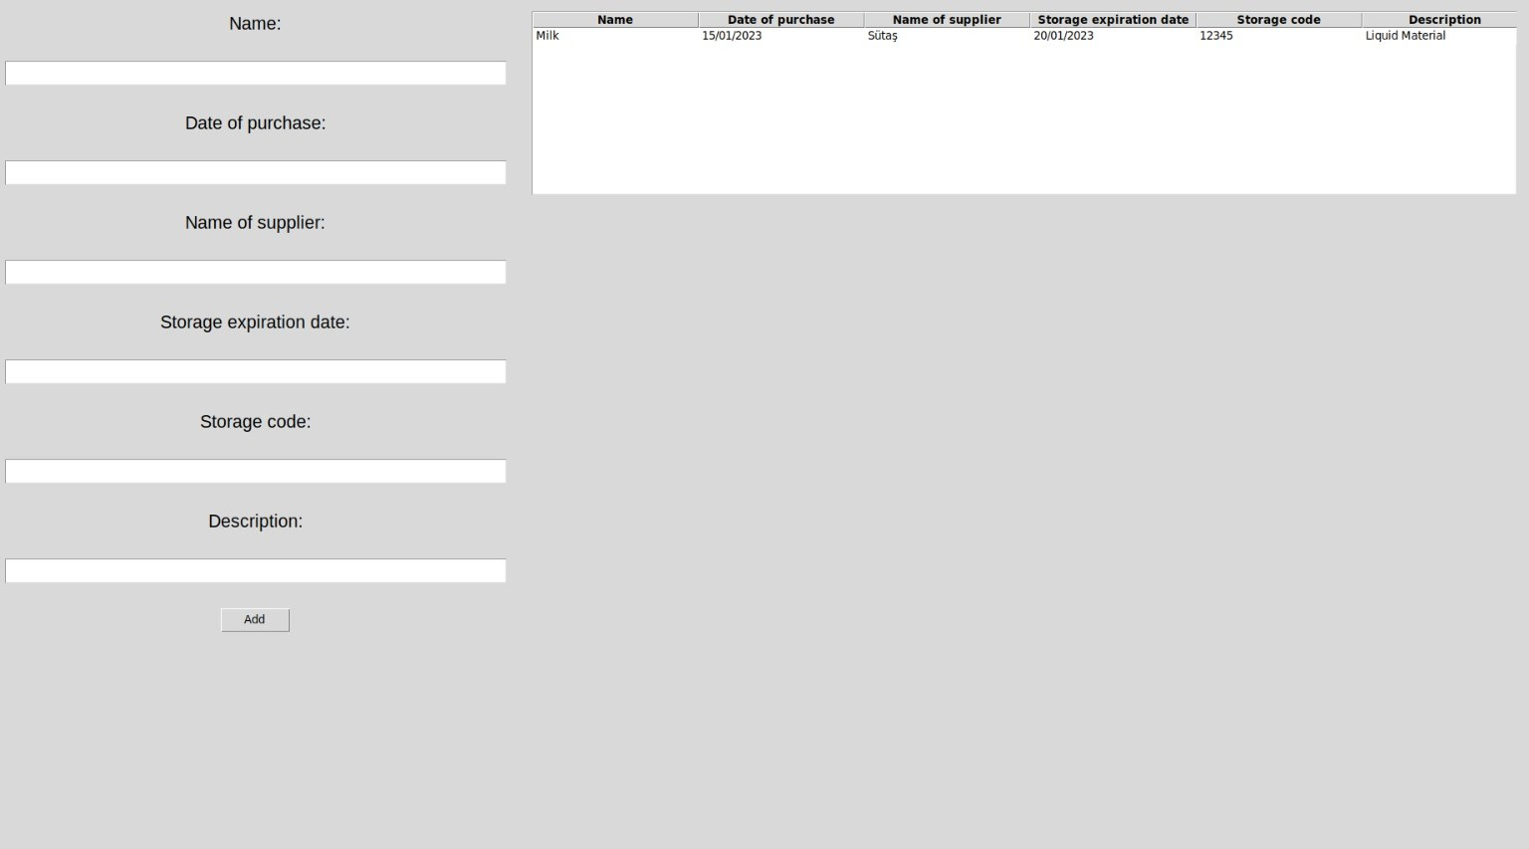

After this process, new item will be in both in the treeview widget and excel file
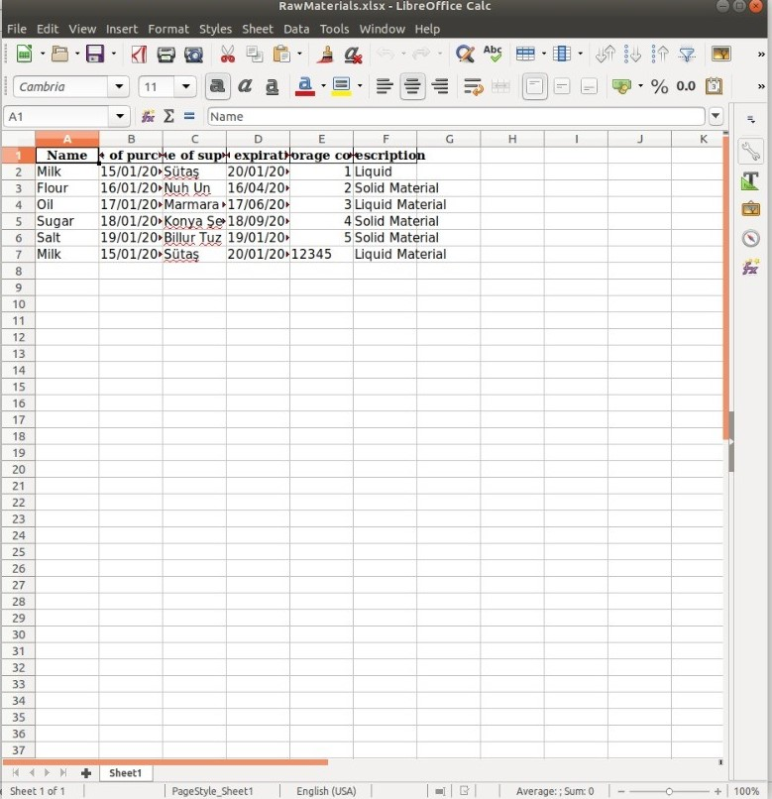

The program’s “Add Product” process is working same as this.

3- Video Processing
After opening this, a window will appear.
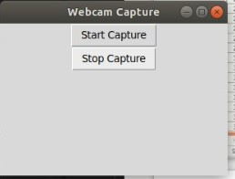

When we press the “Start Capturing”, a video process will start.
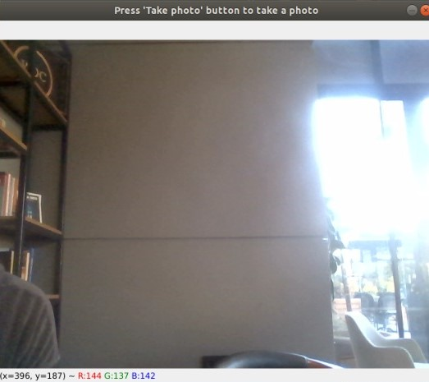

To take a photo, all we need to do is just click the screen then it will capture. After capturing, the program will ask you to name your photo.
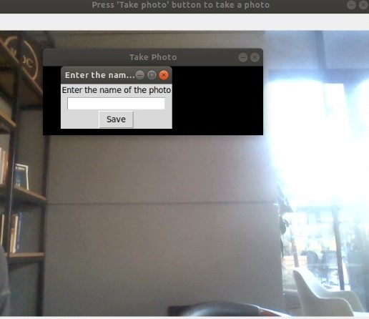

After pressing “q”, the program will be closed.

